DevOps Assignment Documentation: Flask Application with JSON API & MongoDB Atlas Integration
Student Name: Chinmay Pardeshi

Project Folder Name: Flask_and_MongoDB_Chinmay_Pardeshi

Table of Contents
- Project Overview & Objective

- Project Architecture & File Structure

- Environment Setup & Installation

- Task 1: JSON API Route (/api) Implementation

- Task 2: Frontend Form & MongoDB Atlas Integration

- Success & Error Handling Verification

- GitHub Repository Link

1. Project Overview & Objective
The objective of this assignment is to build and deploy a production-grade Python Flask web application featuring:

- Task 1: A backend-backed JSON API route (/api) that reads structured data from a local file (data.json) and returns a JSON list response.

- Task 2: A frontend web form that captures user input, performs server-side validation, connects securely to a cloud MongoDB Atlas cluster using pymongo, and handles both successful insertions (with redirection to a success confirmation page) and error scenarios gracefully (displaying error messages inline on the form page without redirection).

2. Project Architecture & File Structure
The complete project source code is organized inside a single root folder named Flask_and_MongoDB_Chinmay_Pardeshi:
Plaintext
Flask_and_MongoDB_Chinmay_Pardeshi/
├── app.py
├── data.json
├── requirements.txt
├── templates/
│ ├── index.html
│ └── success.html
└── README.md
3. Environment Setup & Installation
Step 3.1: Python Dependencies
The application requires Flask for web routing and rendering, PyMongo for MongoDB Atlas communication, and DNSPython for SRV cluster URI resolution.
- Dependencies File (requirements.txt): Includes Flask, PyMongo, and DNSPython pinned to their respective stable versions.
- Installation Command: Open your terminal inside the project root directory and execute the pip install command pointing to the requirements file.
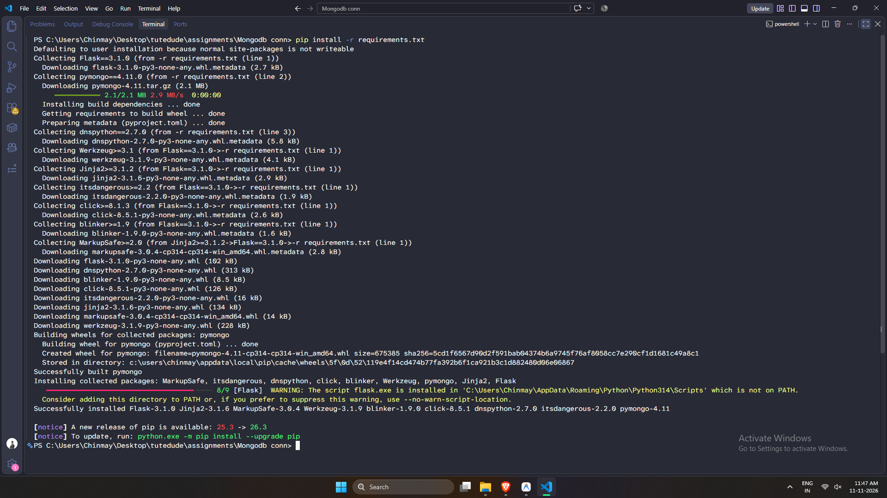

4. Task 1: JSON API Route (/api) Implementation
Implementation Details
The /api route reads records dynamically from the backend data file (data.json) and serializes them into a standard HTTP JSON list response.

- Backend Data File (data.json): Stores sample structured records containing identification numbers, module names, operational status flags, and descriptive details.

- Flask API Route Logic (app.py): The route checks for the existence of the JSON data file, reads its contents securely using UTF-8 encoding, parses the JSON structure, and returns it with a 200 OK status code, returning structured error dictionaries with appropriate HTTP status codes upon failure.
- Verification: With the server running, navigating to the /api endpoint in the browser or via command line returns the expected JSON payload. 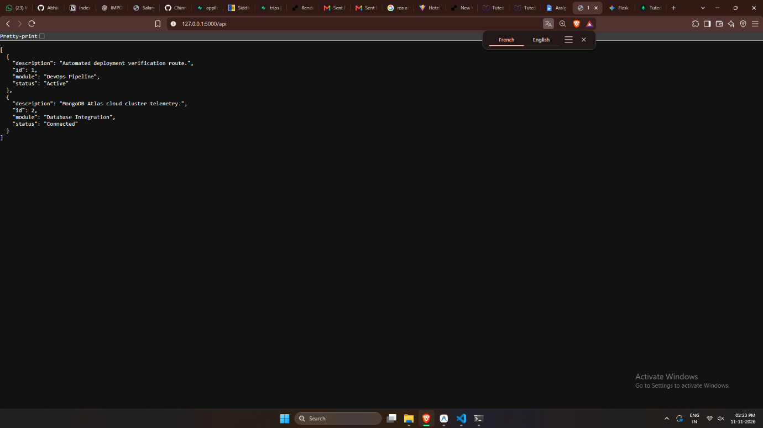

5. Task 2: Frontend Form & MongoDB Atlas Integration
Implementation Details
Task 2 connects the user interface to MongoDB Atlas. Submissions are processed securely via HTTP POST requests.

- MongoDB Connection & Form Handling (app.py): Establishes a connection to the MongoDB Atlas cloud cluster using a secure SRV connection string with server selection timeout settings. The submission route extracts form parameters, sanitizes inputs, performs server-side null or empty checks, constructs a dictionary document, inserts it into the target collection, and triggers a redirection on success or catches exceptions to render error banners.

- Frontend Form Template (templates/index.html):

  - Captures user input fields including name, email address, and project notes/messages.

  - Features conditional Jinja2 error banners to display errors inline on the same page without redirection.

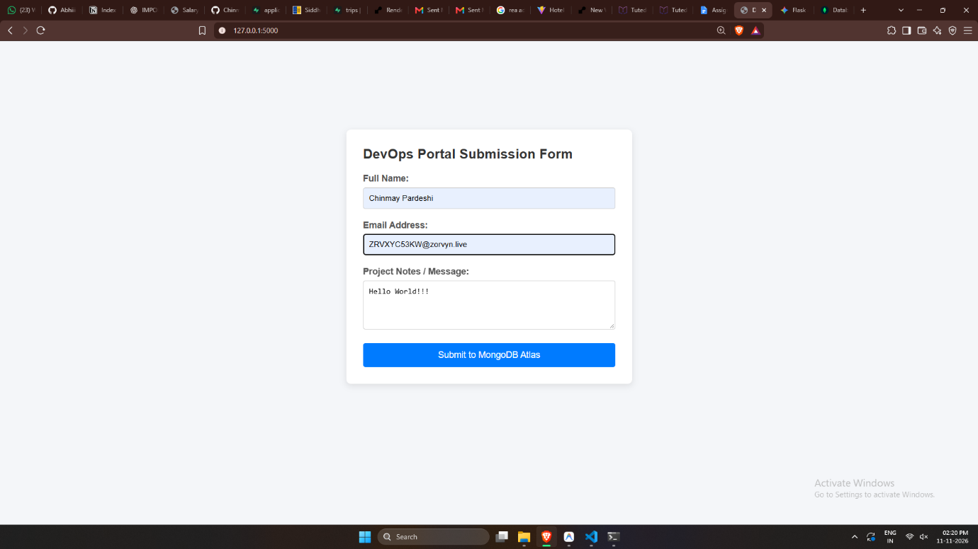

- Success Confirmation Template (templates/success.html):

  - Redirects upon successful document insertion to display the mandatory success message: “Data submitted successfully”.
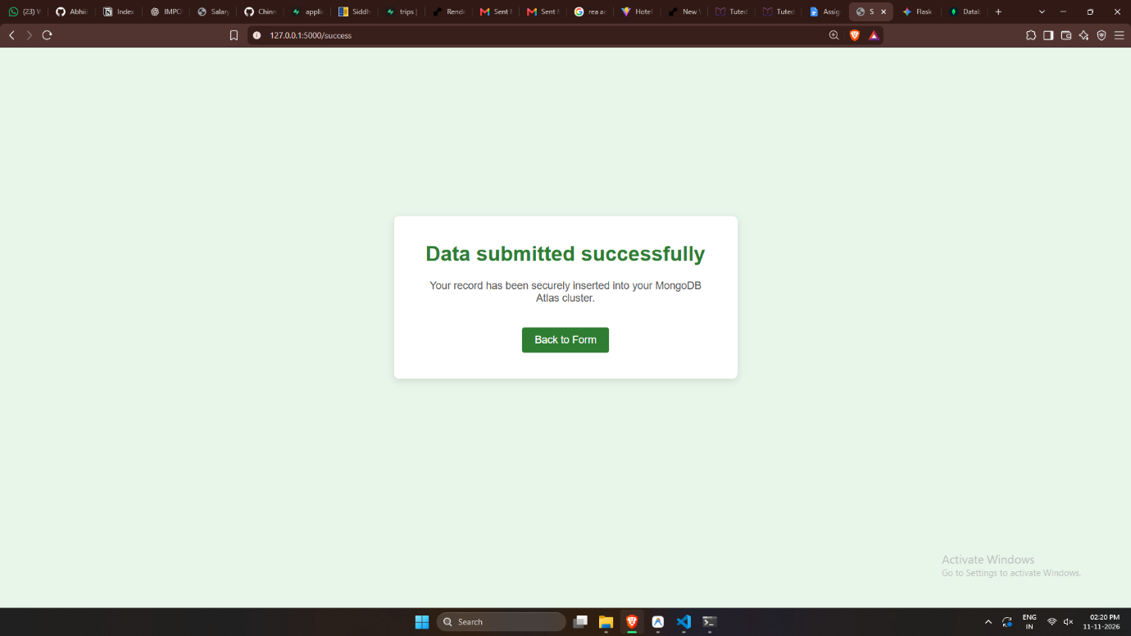

- MongoDB Atlas Data Explorer Verification:

  - Documents written by the Flask form populate the target collection in real-time.
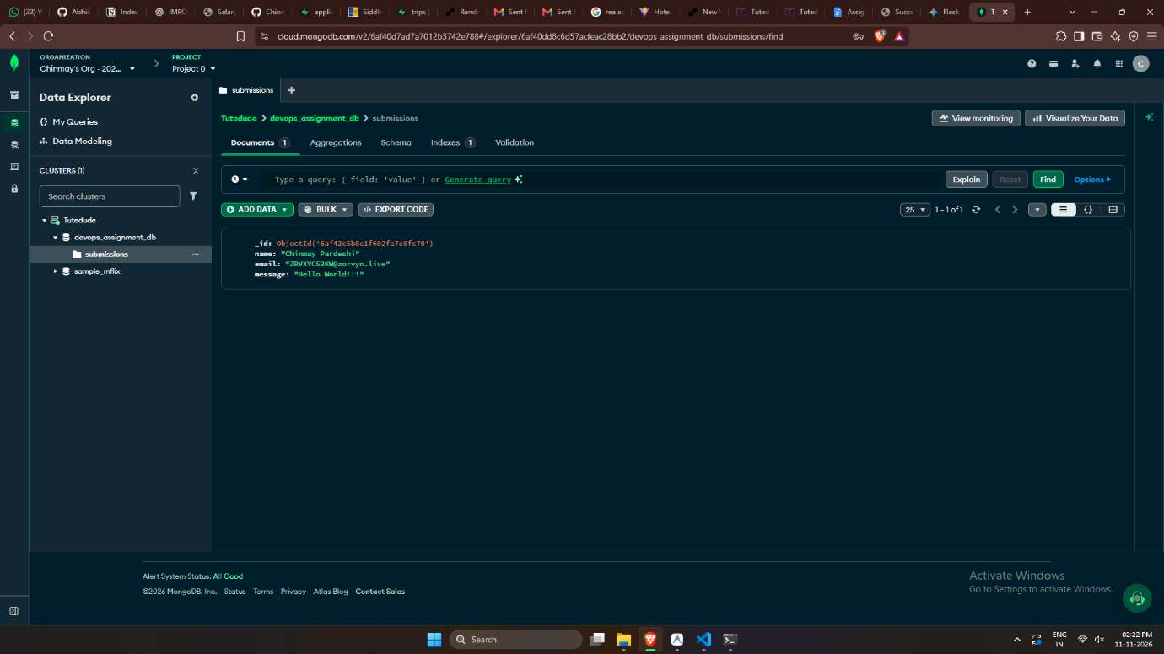

6. Success & Error Handling Verification
- Success Scenario: Valid inputs submitted through the form trigger document insertion into the cloud database, redirecting the user to the success view and displaying the confirmation message.

- Error Scenario: Missing parameters or database connectivity interruptions trigger the exception handling block, rendering the input form with an alert banner detailing the error on the same page without redirection.

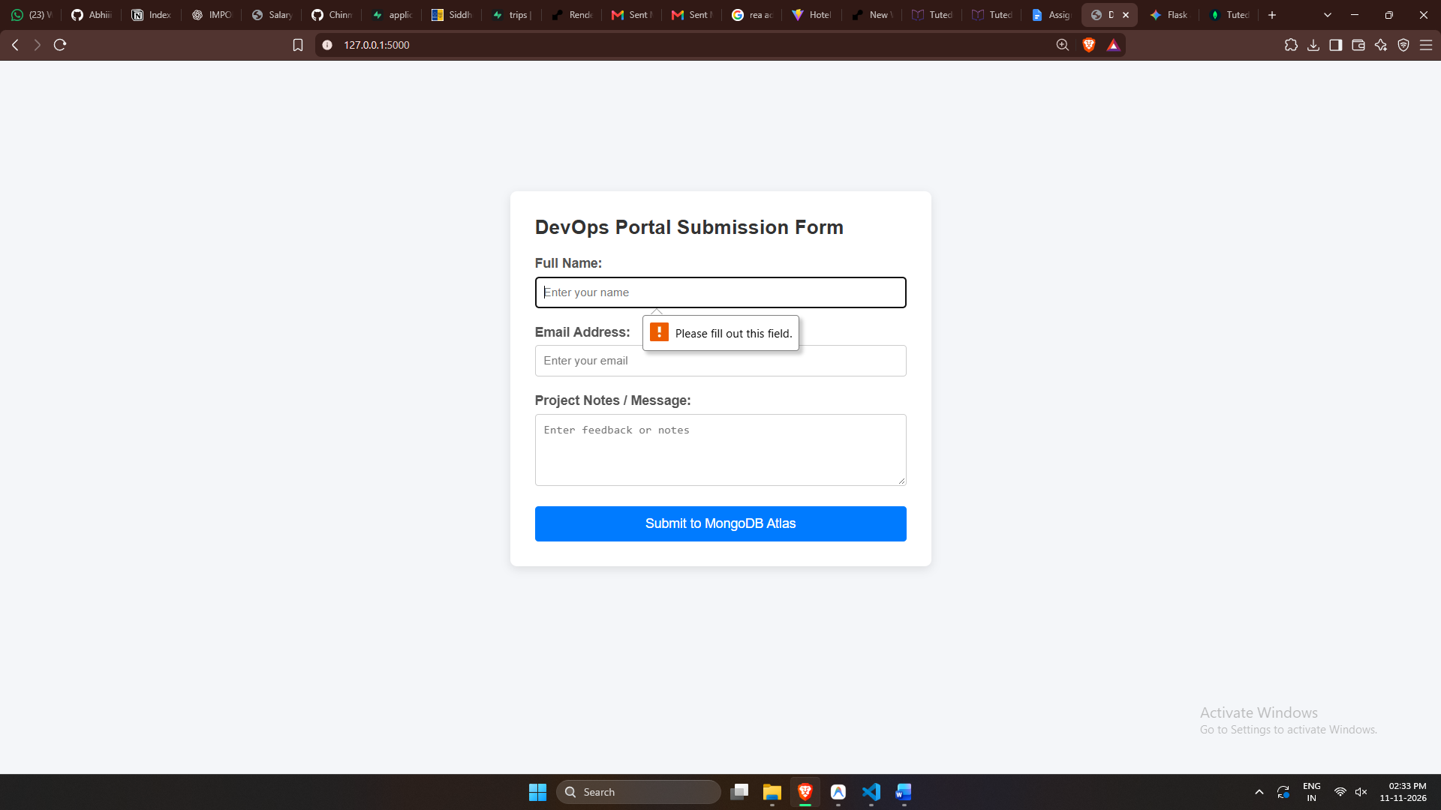

7. GitHub Repository Link
- Public Repository URL: https://github.com/Chinmaypardeshi/Tutedude/tree/main/Devops/Assignment%203

